8]after performing the test failover I say I have a healthy failover status

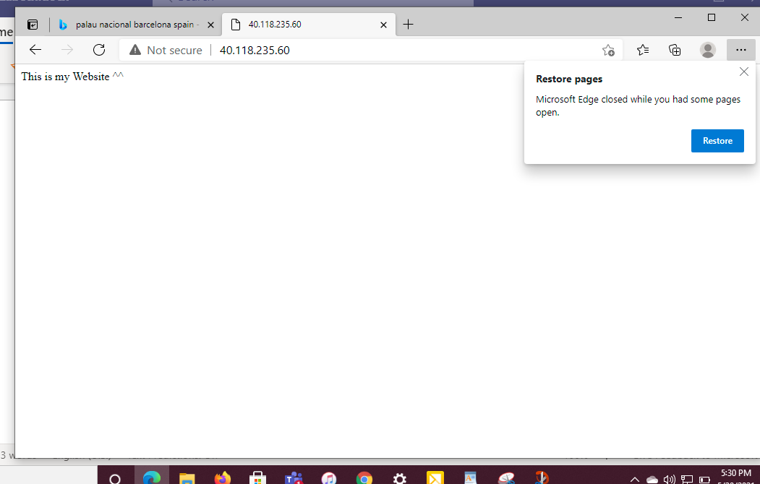

The image above shows a copied public address confirmed on my network